**Other Support Tool**

**Full introduction/Instructions:**

<https://researchservices.upenn.edu/using-penns-other-support-tool/>

**For the Other Support Tool to effectively work Pi’s must:**

* Update profile in PennERA to include eRA Commons ID
* Complete a brief description in the PI Certification at the time of submission. This will auto fill the Major Goals on the Other Support.



**Login using Pennkey ID and password**:

<https://apps.research.upenn.edu/login>

**Select Grants & Contracts/Current & Pending Management:**

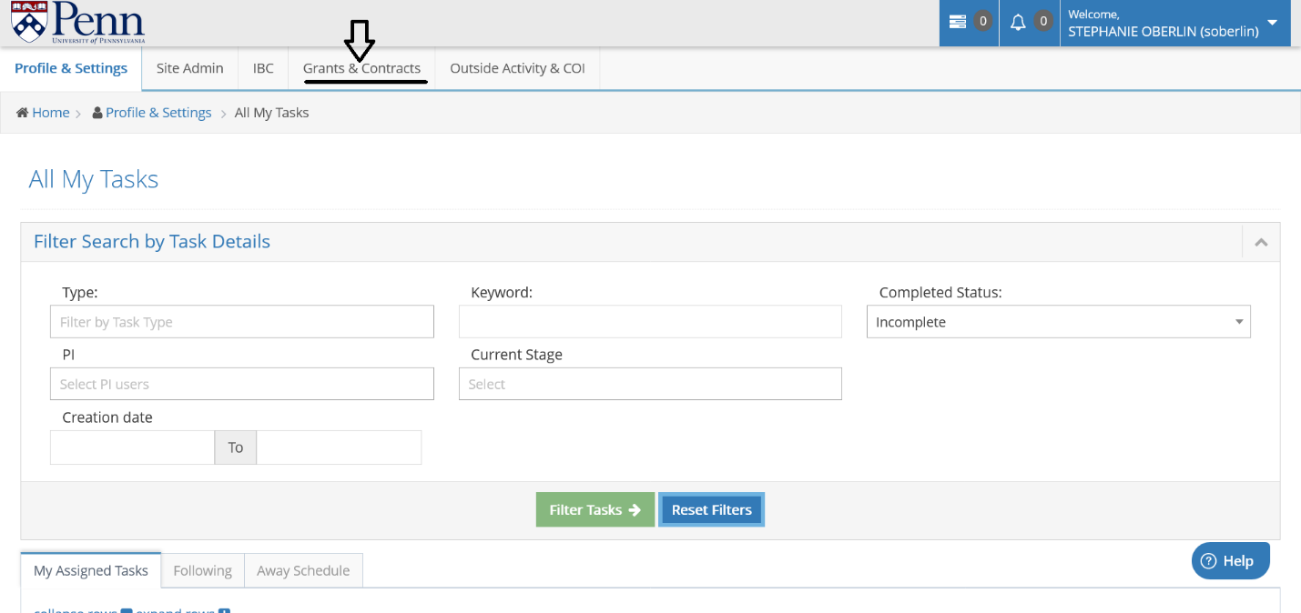

**Select Researcher from drop down menu (begin typing to see list):**

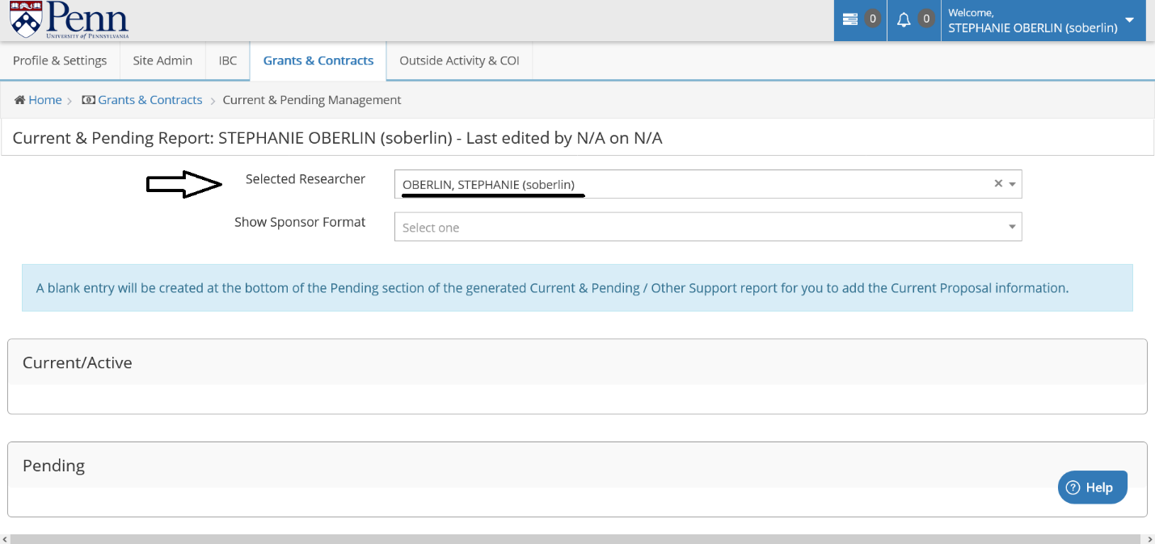

**Select Sponsor Format from drop down menu:**

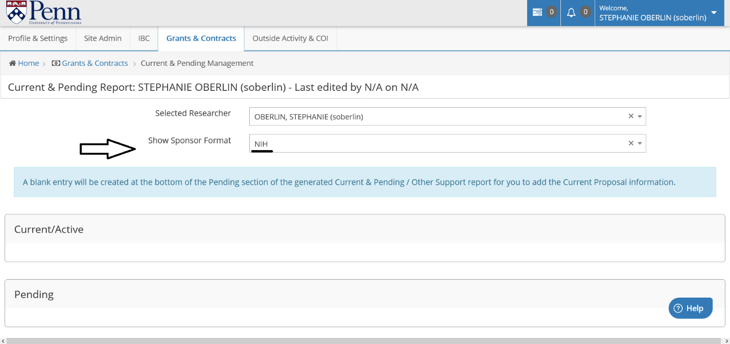

**Scroll down and select applicable projects to include on your Other Support** from the following sections – Current/Active, Pending, Previous Five Years (DOD), & Other Sources of Support (Reporting of active In-Kind contributions is required):

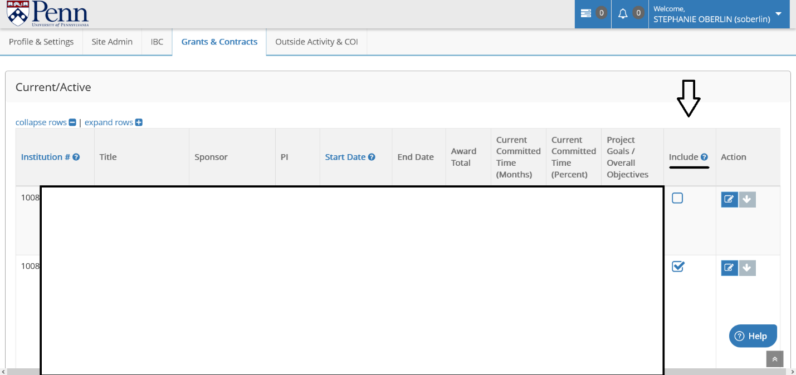

**Use the Action button to make changes to active awards.** *Please note that changes can only be made in the system if an award is active in PennERA* If an award is not active in our system (Ie. Amendment agreement has not be executed), changes must be made after the report is exported.

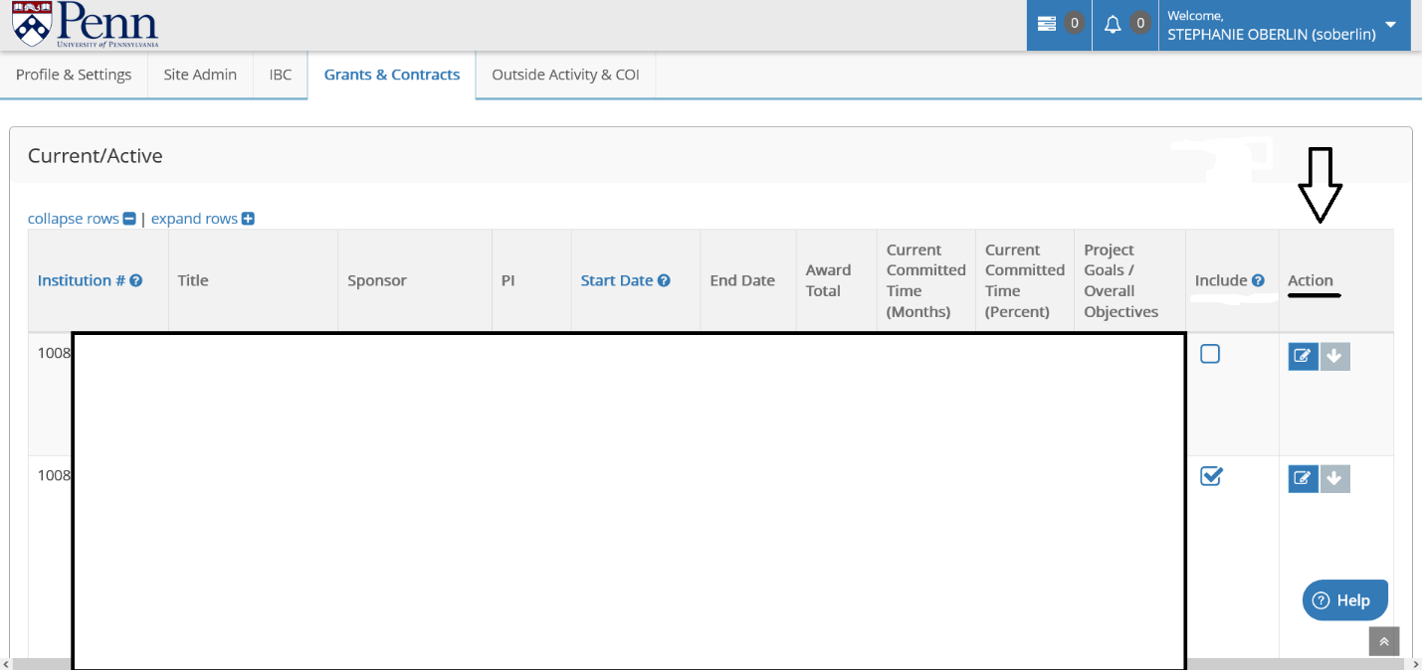

**Other Sources of Support, including internal awards and in-kind are manually entered:**

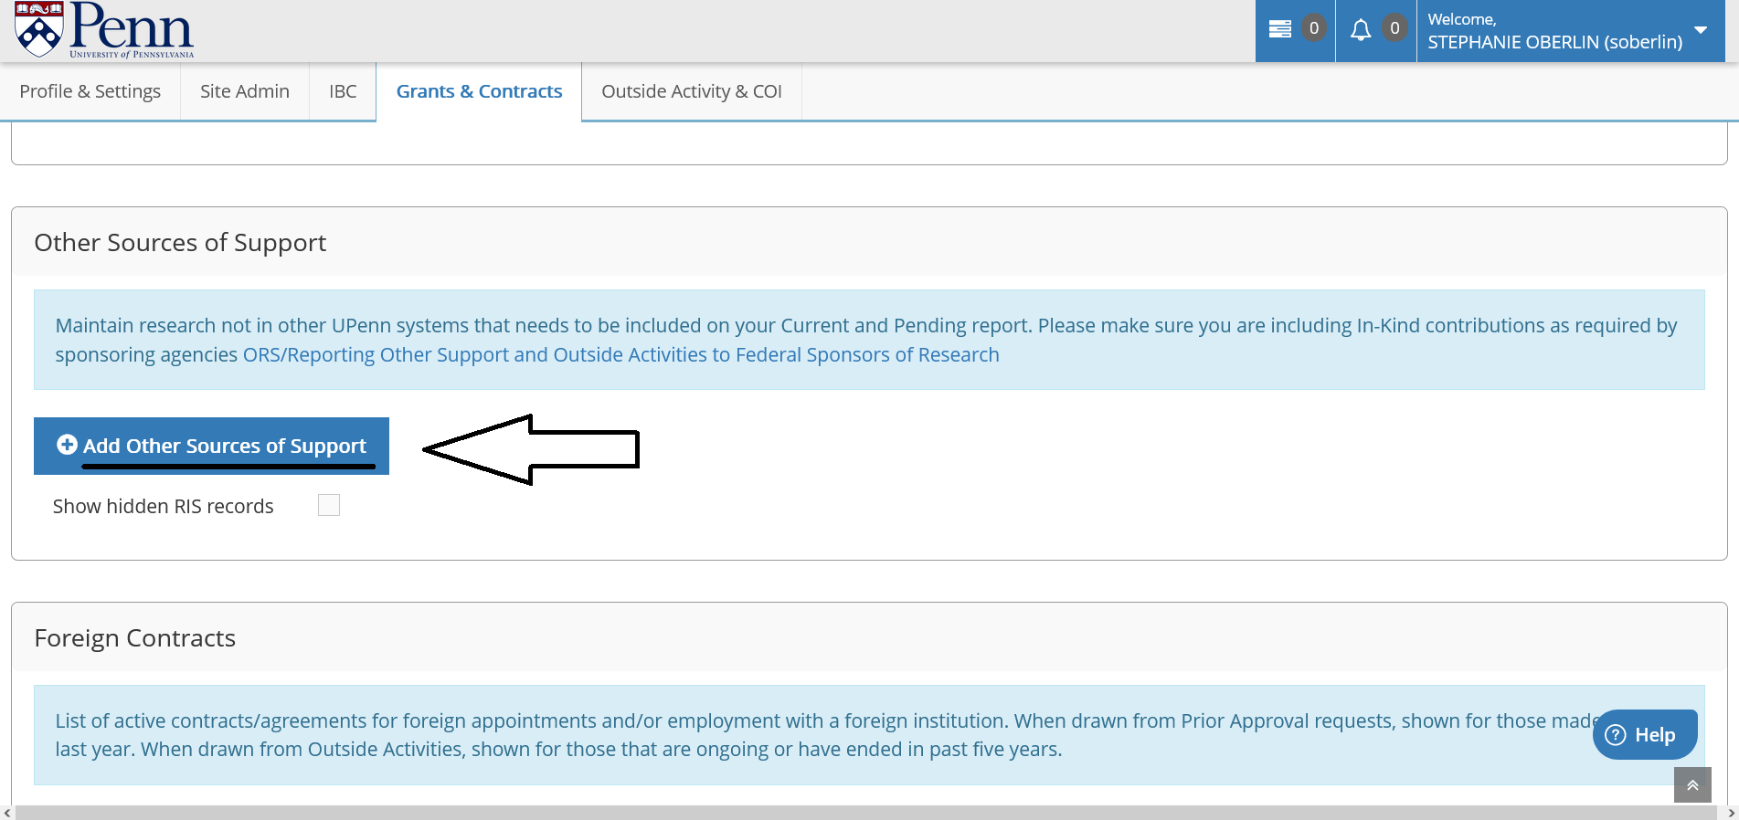

**Save changes before exiting pop-up screens:**

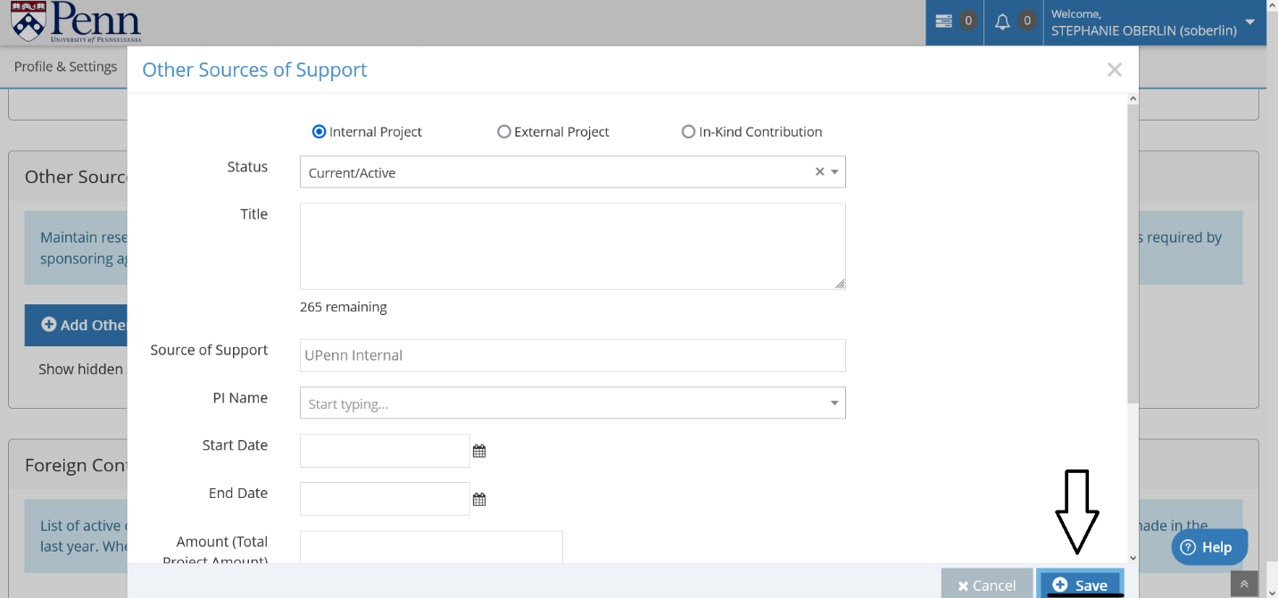

**Print Report**

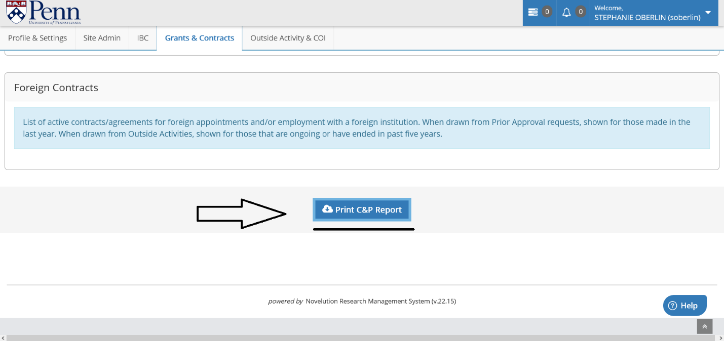

**Review the downloaded report and make any adjustments needed to the final Other Support.**